**DESIGN DEVELOPER TRAINEE**

**at TETRA PAK Vietnam**

**About Us**

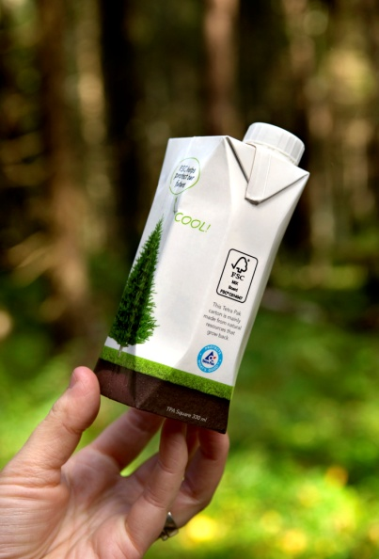**TETRA PAK** is the world's leading food processing and packaging solutions company. Working closely with our customers and suppliers, we provide safe, innovative and environmentally sound products that each day meet the needs of hundreds of millions of people in more than 170 countries around the world. With almost 22,000 employees based in over 85 countries, we believe in responsible industry leadership and a sustainable approach to business. Our motto, “PROTECTS WHAT’S GOOD®," reflects our vision to make food safe and available, everywhere.

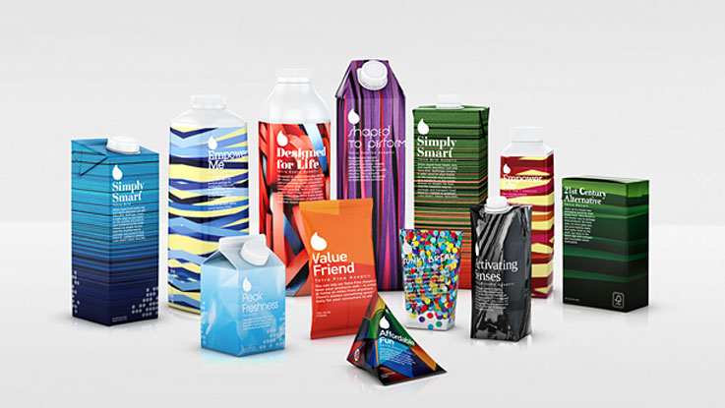

**Our Core Values**

* Customer Focus & Long-Term View
* Quality & Innovation
* Freedom & Responsibility
* Partnership & Fun

Position: **DESIGN DEVELOPER TRAINEE**

**ABOUT THE PROGRAM**

* Full time as permanent job
* Working hour: 8:00 AM – 5:00 PM, Mon – Fri
* Working location: Ho Chi Minh
* Required Start Date: Can start immediately
* Number of hire: 1

**BENEFITS**

Tetra Pak Vietnam offer the attractive salary and benefits such as 13th month salary, Performance Incentive, Health Insurance, Lunch allowance, Transportation allowance, Health Club Membership, etc.

**OVERVIEW OF THE POSITION**

Translating customer artwork and intenting to a repro order following the Repro Submission Guidelines and Tetra Pak specifications, satisfying customers and productivity demands. Supporting Customer Service Representative in graphical knowledge and with customer and design agencies drive right first time according to Tetra Pak design manual and other graphical guidelines.

Main

**MAIN RESPONSIBILITIES AND OBJECTIVES**

1. **Drive improvements of customer artwork quality, suitability and process**
   * Drive artwork quality, suitability and end to end design process improvements
   * Drive design seminar and trainings
   * Capture and share good practices in market and cluster network
2. **Manage / Perform conversion of artwork file to proof**
   * Pre-flight and complete full design evaluation of customer artwork files
   * Ensure that our printing specification and OOS process are followed and respected
   * Understand customer intent and translate this to repro instruction, maximizing print quality depending on print method, while securing production efficiency
   * Secure design consistency for brand / family designs
   * Check that repro has completed the job according to all requirements and verify that customer intent is fulfilled
3. **Support design handling process**
   * Lead Design handling performance, deploy and suggest improvements activities
   * Participate in team work to improve design handling performance
   * Support CSR with graphical knowledge

**QUALIFICATIONS**

* At least Degree in Printing Technology or Diploma in Graphic Design. Experience of study abroad is an advantage
* Fresh graduation or having less than 2 years working experience of design, repro or printing related industry
* Strong knowledge with Graphic arts software, such as Adobe Illustrator, Photoshop
* Person with proven competence to work in a structured way following processes and guidelines
* Ability to work independently, self-motivated, good team-player with an eye to details
* Strong communication and interpersonal skills to interact with internal and external stakeholders with ability to manage customers
* Fluent English in both verbal and written communication

**CONTACT FOR APPLICATION**

Please send your Resume to Ms. Nhung Nguyen – Recruitment Assistant

**Email:** recruit.vn@tetrapak.com

**Tel:** 0121.8924.023